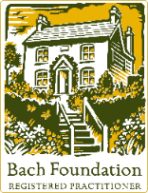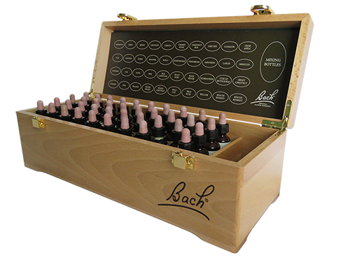

**FREE TALK**

**Bach Flower Remedies for Stress**

|  |  |
| --- | --- |
| ✓ | Dr Bach, his Philosophy of healing and Principles of the Bach system |
| ✓ | The 38 remedies and their emotional states |
| ✓ | How to choose remedies for common symptoms of stress e.g., anxiety, anger, insomnia and overwhelm |
| ✓ | The Emergency Mix - for acute situations |
|  |  |

**Pauline Wickens** BFRP MVHF MFSEM**Bach Flower Registered Practitioner**✉ harmony@chf.energy🖱 https://chrysalishealingfoundation.co.uk☎ 07895 079278

Date : Thursday 23rd May 2024

Time : 6:30pm to 8:00pm

Venue : Isbourne Wellbeing Centre, 2 Wolseley Terrace, GL50 1TH

Price : FREE

***Please reserve your place by calling 01242-254321***

We will embark on a journey of discovery which will include: -

*Natural plant essences providing emotional support during challenging times*